Circuit Analysis (Lab5) Experiment 5: Introduction to Proteus

Name: Muhammad Zia Ur Rehman Zahid Registration No: 2025-CE-104
Date: 04-April-2026 Grade and Signature: ………………………
CLO2  CLO3 | Use with identification the circuit components, breadboards, multimeters, power supplies, signal generators, and oscilloscopes. Make measurements in their own constructed electric circuits.  (All above CLO’s are attained through simulation)
Psychomotor/Affective | Level1 (1) | Level2 (2-3) | Level3 (4-5) | Level4 (6-7)
Report Marks (3) |  |  | Total marks  (10)

Objectives: To get understanding of how to use a Proteus to simulate your circuits and verify outputs.

Equipment required: A computer with proteus installed on it.

The PROTEUS Environment:
Proteus PIC Bundle is the complete solution for developing, testing and virtually prototyping your embedded system designs based around the Microchip Technologies TM series of microcontroller. This software allows you to perform schematic capture and to simulate the circuits you design.
A demonstration on the use of PROTEUS will be given to you on this lab session, after that; you are encouraged to learn to use the software interactively.
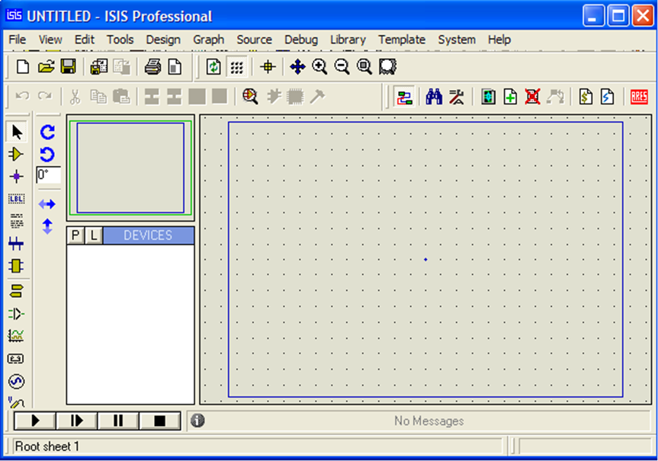
Status bar
EditingWindow
Animation panel
Object Selector
Overview Window
Figure 1 A screen shot of the Proteus IDE

Proteus How to Start Drawing the Circuit
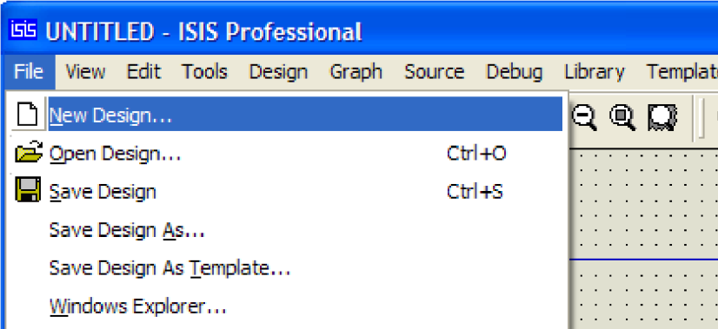
Start a fresh design, select New Design from File menu then the Create New Design dialogue now appears as shown in Figure 2 and 3. Select Default and press OK.

Figure 2 Creating a new design
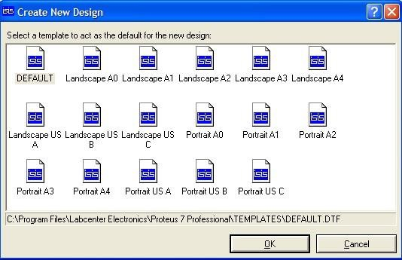
Figure 3 Select a template

From the Library menu select Pick Device/Symbol see Figure 4 or Left click on the letter ‘P’ above the Object Selector as shown in Figure 5 to launch the Library Browser or Press the 'P' button on the keyboard. The Library Browser will now appear over the Editing Window see Figure 6.
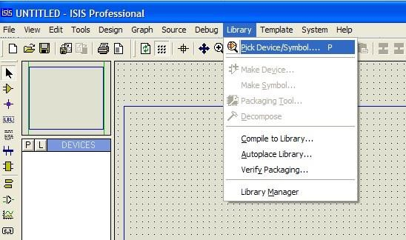
Figure 4

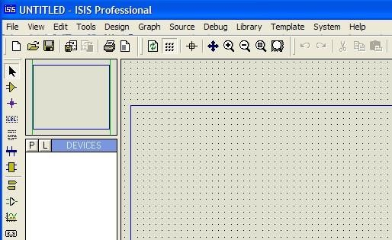
Pick device
Figure 5

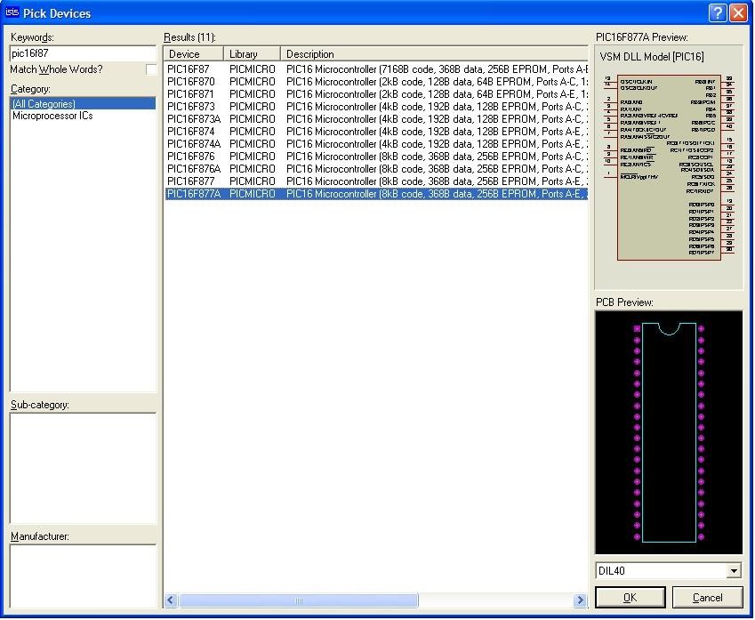
Figure 6 Library Browser
Type ' PIC16F877A ' in the Key words field and double click on the result to place the PIC16F877A into the Object Selector.

Type ' PIC16F877A ' in the Key words field and double click on the result to place the PIC16F877A in to the Object Selector. Do the same for the LEDs, Buttons, Crystal oscillator, capacitors, 7 SEG-COM- Cathode, Resistors.

Once you have selected all components into the design close the Library Browser and left click once on any component in the Object Selector
(This should highlight your selection and a preview of the component will appear in the Overview Window at the top right of the screen see Figure 7). Now left click on the Editing Window to place the component on the schematic - repeat the process to all components on the schematic.
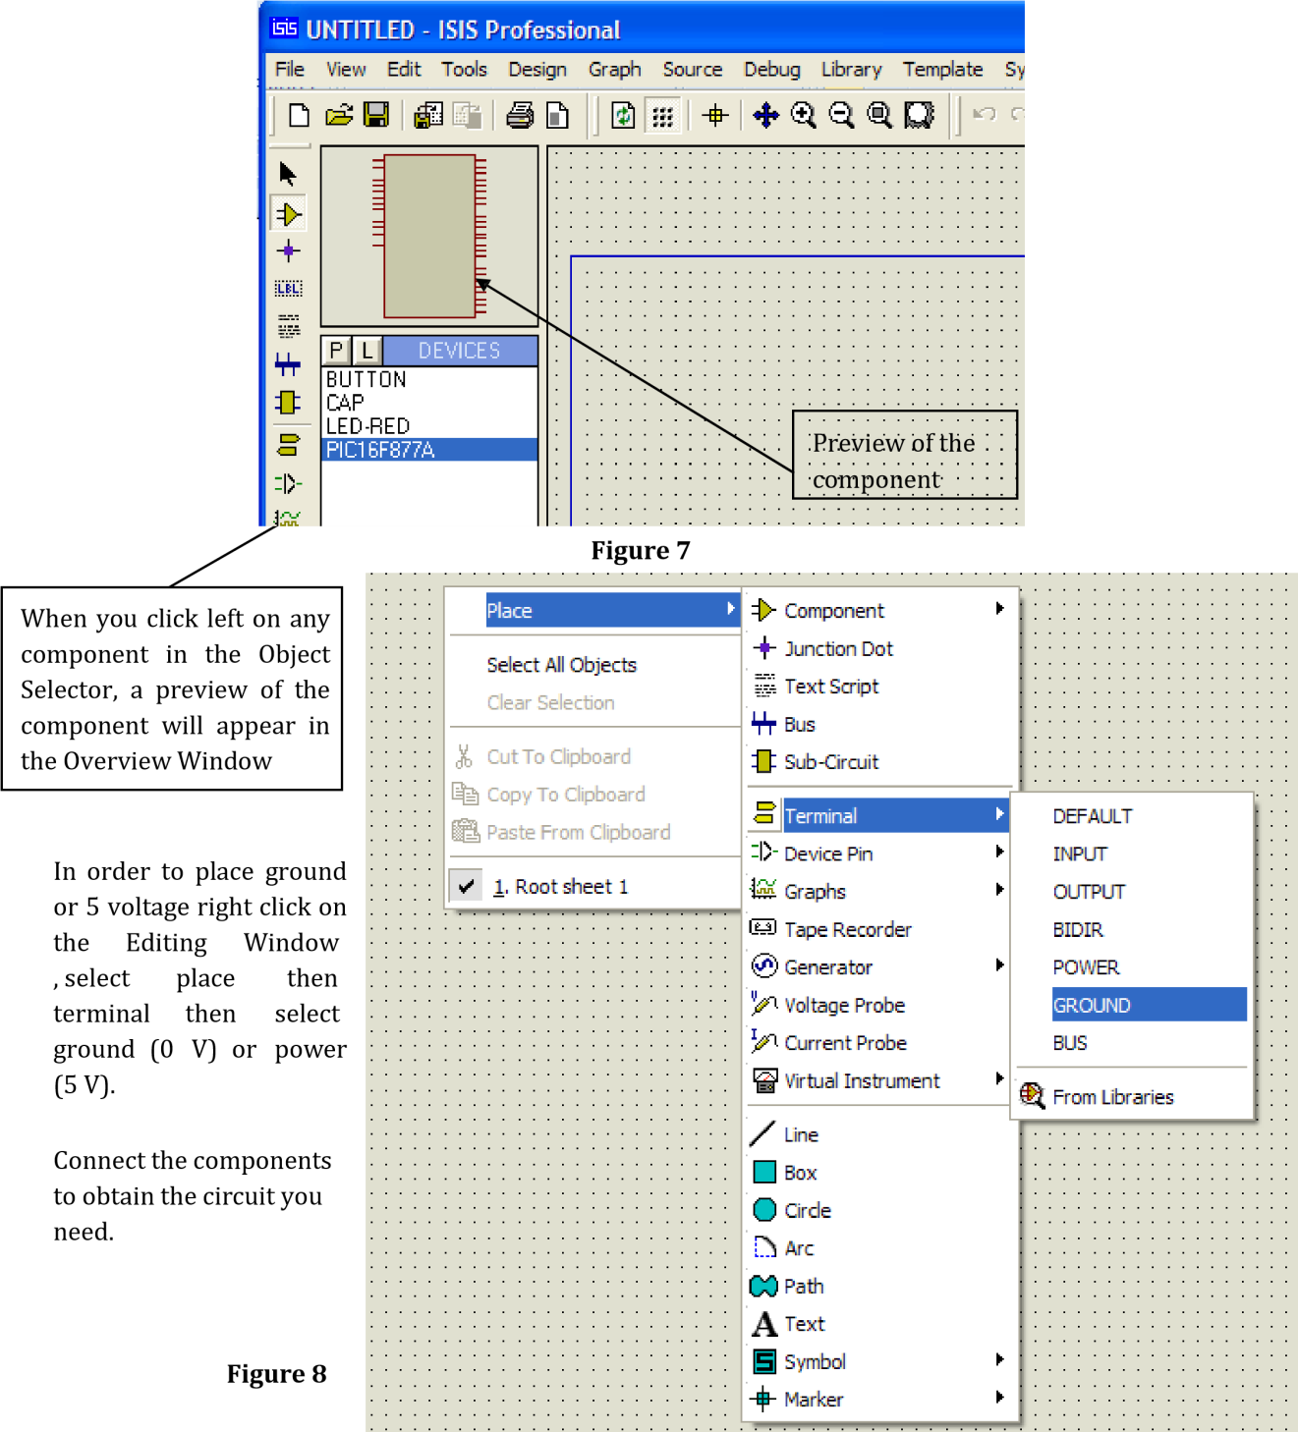

Demo Project:
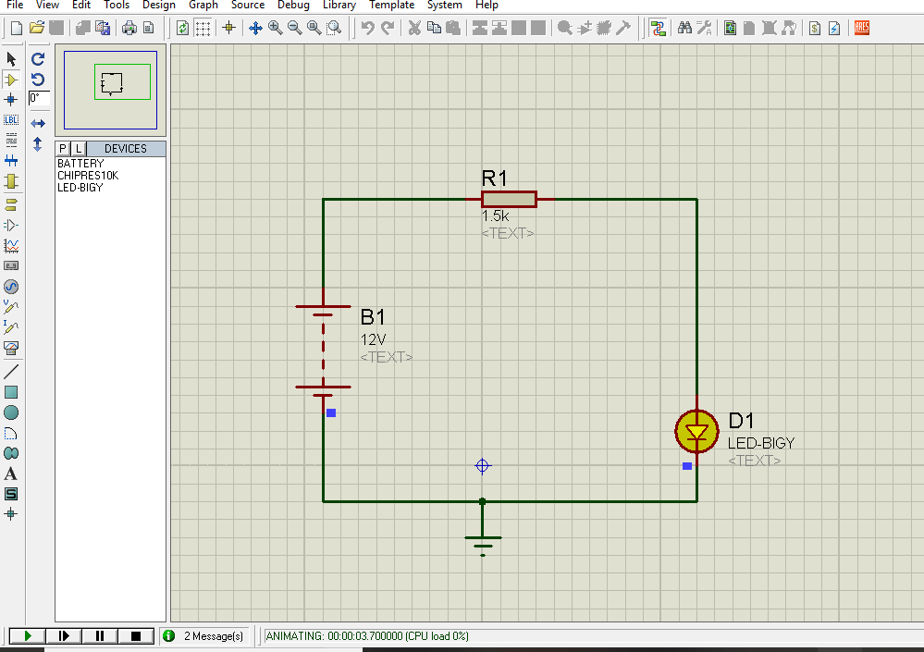

Lab Tasks:
Create following circuit and simulate using Proteus.
- Measure Current between R1 and R2, and Voltage across R1, R2.
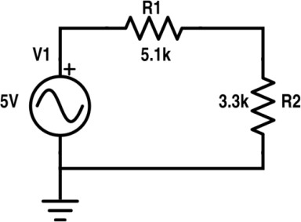

Simulated Values:

R1 Voltage | R2 Voltage | Current
2.14V | 1.39V | 0.42mA

- Measure Current across R1, R2, R3 and Voltage between node 2 and 3.
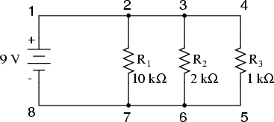
Simulated Values:

R1 Current | R2 Current | R3 Current | Voltage
0.9mA | 4.5mA | 9mA | 9V

Post Lab Task:
